|  |
| --- |
| **Audit Name: Production Support (PBM/Specialty)**  **Audit Number: 21303**  **Prepared By: Seun Mafi**  **Date Completed:** |

|  |  |
| --- | --- |
| Control & Sample Information | |
| Control | B.1 – User Access Appropriateness |
| Sample Number | 19 out of 185 active cognizant employees. |
| Supporting Documentation Received From | Ganesh Gouthamchand (Director, PBM IT Systems)  Michael Reese (Director, IT Systems PBM CMS Service Delivery)  Michael Fritz (Manager, Data Science)  Michael ONeill (Director, IT Systems, RXClaim) |
| Received Date | 07/21/2021, 08/23/2021, 9/2/2021, 9/8/2021 |
| Purpose of the Test | The purpose of this test is to ensure that Cognizant personnel access to ServiceNow and other CVSH applications is restricted based on a user’s job responsibility and managed by CVSH Production Support management team to ensure appropriateness |
| Source Files | [Cognizant User List](https://cvshealth.auditboardapp.com/download?file_id=112239&name=Cognizant%20User%20List.xlsx) 07/21/2021  [Cognizant User Application Access List](https://cvshealth.auditboardapp.com/download?file_id=124406&name=Task%2010956.xlsx) 08/23/2021  [IT Production Support Exceptions](https://cvshealth.auditboardapp.com/download?file_id=125095&name=IT_Production_SupportExceptions.xlsx) 09/2/2021  [HR User Access Listing Email thread](https://cvshealth.auditboardapp.com/download?file_id=125085&name=RE%2021303%20-%20Production%20Support%20(PBMSpecialty)%20-%20HR%20User%20Access%20Listing.msg) 09/2/2021  [Application Evidence #3](https://cvshealth.auditboardapp.com/download?file_id=125147&name=B.1%20%26%20B.2%20%E2%80%93%20Application%20Evidence%20%233.msg) 09/08/2021  [CTS Access RxClaim Tier 1](https://cvshealth.auditboardapp.com/download?file_id=125207&name=IT-001_v14.06_CTS%20Access_RxClaim%20Tier%201_Basil%20%20Nrupal.docx) 09/08/2021  [NLX Individual Internal User Access Request form](https://cvshealth.auditboardapp.com/download?file_id=125208&name=FW%20New%202020.Copy%20of%20NLX_Individual%20Internal%20User%20Access%20Request%20Form%20v.6.xlsm.msg) 09/08/2021  [Copy of NLX Individual Internal User Access Request form](https://cvshealth.auditboardapp.com/download?file_id=125214&name=Karthik_Valapala_2020.Copy%20of%20NLX_Individual%20Internal%20User%20Access%20Request%20Form%20v.6.xlsm) 09/08/2021  [FW Requesting Access Novologix](https://cvshealth.auditboardapp.com/download?file_id=125216&name=FW%20Requesting%20access%20-%20Novologix.msg) 09/08/2021  [Novologix Application – Read only access](https://cvshealth.auditboardapp.com/download?file_id=125217&name=RE%20Novologix%20application%20-%20Read%20only%20access.msg) 09/08/2021  [Ureq400516 TmTrack](https://cvshealth.auditboardapp.com/download?file_id=125225&name=UReq400516%20tmtrack.pdf) 09/08/2021 |

**Attribute 1: Obtain a system generated list of Cognizant users to ServiceNow to ensure Access is appropriate based on Job responsibility, and ensure:**

1. **User’s Access is active**
2. **If any non-active employees are still listed, obtain the count to share with our audit partners.**

On 7/12/2021, IA received from Ganesh Gouthamchand (Director, PBM IT Systems) a full list of active Cognizant employees [Cognizant User List](https://cvshealth.auditboardapp.com/download?file_id=112239&name=Cognizant%20User%20List.xlsx). IA observed that there are a total of 185 active users grouped into three major towers namely; Adjudication Services, MMCS and Specialty. *See below:*

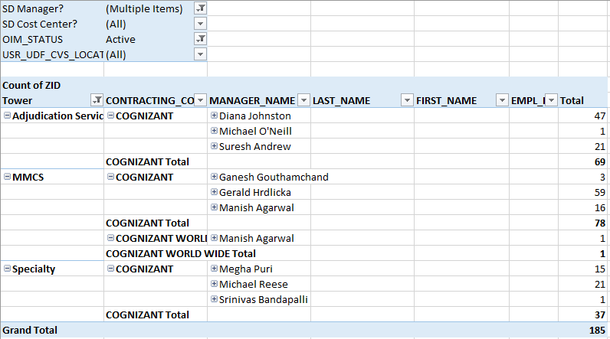

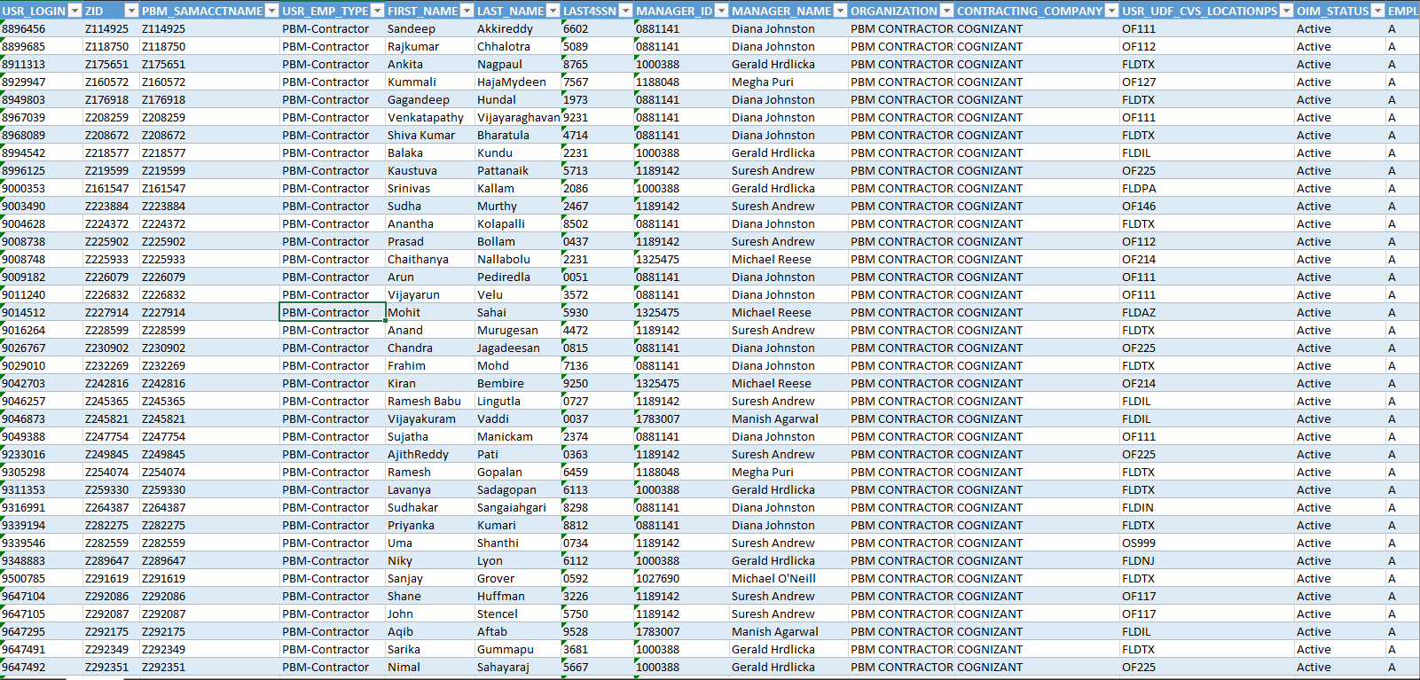

IA also consulted the Data Analytics team to obtain an HR listing of all active Cognizant users. On 9/2/2021, Michael Fritz (Manager, Data Science) provided a manually reconciled list of all active cognizant users within the HR Listing. IA observed that there were 88 Cognizant employees with active status but were not able to match to HR/Global Directory Information. Michael noted that of the 10 employees from the 88 active employees, 9 employees were not found in the system (Outlook) and 1 was not in the system either but there was a contractor working for Cognizant with the same first and middle name with a different last name (possibly married or could be a completely different person). *See email thread for reference* [HR User Access Listing Email thread](https://cvshealth.auditboardapp.com/download?file_id=125085&name=RE%2021303%20-%20Production%20Support%20(PBMSpecialty)%20-%20HR%20User%20Access%20Listing.msg).

Following HR user listing reconciliation carried out by the DA Team, IA noted that 10 Cognizant employees pulled out from the Cognizant user listing provided by Ganesh Gouthamchand (Director, PBM IT Systems)

were not found in the system.

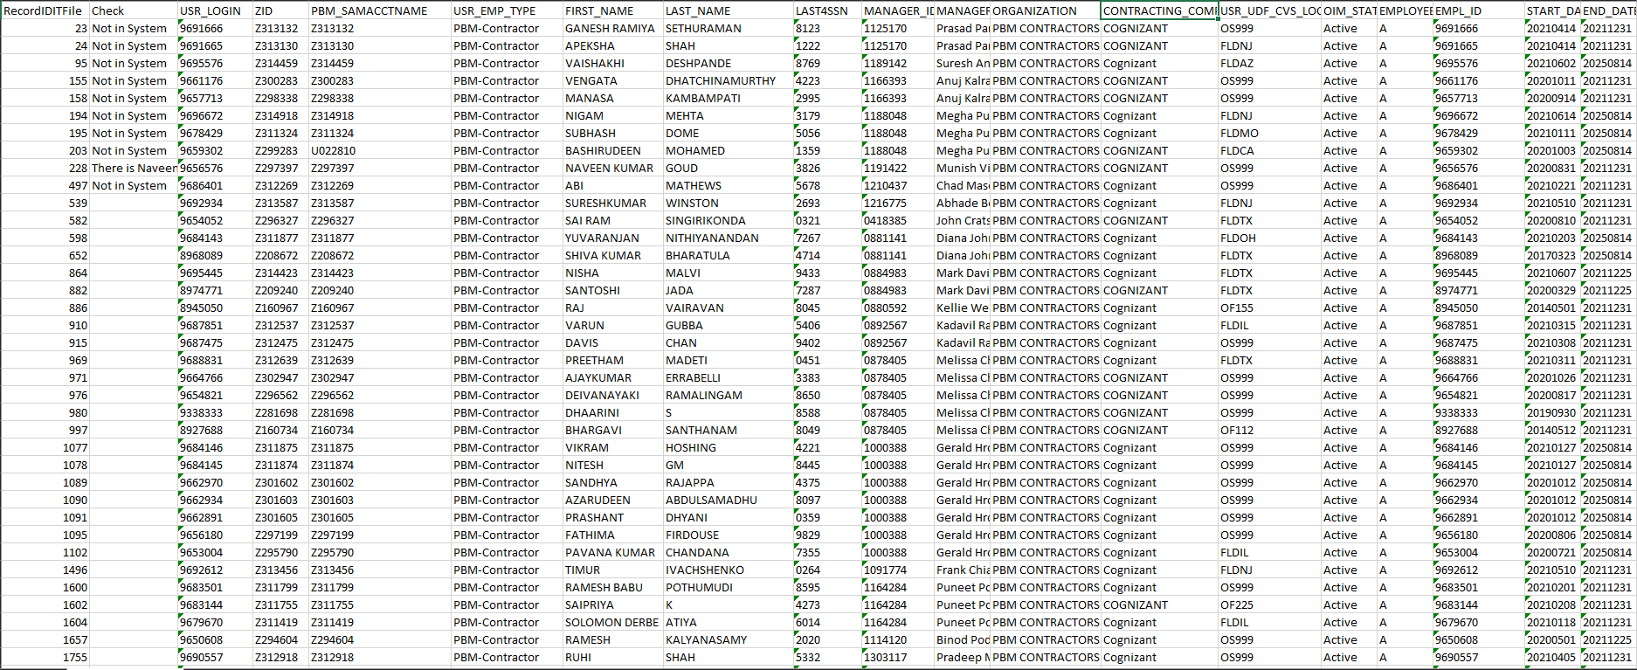

IA noted that 10 Cognizant employees pulled out of the Cognizant user listing provided by Ganesh Gouthamchand (Director, PBM IT Systems) were not found in the system as noted in the HR listing provided by the DA Team. IA did not gain full assurance that the user listing maintained by Cognizant reflects an updated list of active cognizant users.

Attribute not satisfied.

**Attribute 2: Sample a set of active users (Including subset of offshore users) and obtain a list of applications to which they have access and ensure that the level of access is based on their job responsibility.**

Per IA methodology, a 10% sample was drawn out from the total cognizant employee listing of 185 ([Cognizant User List](https://cvshealth.auditboardapp.com/download?file_id=112239&name=Cognizant%20User%20List.xlsx)). This accounted for a sample of 19 active cognizant employees in total. IA then sampled 8 users from the MMCS tower given it had the largest number of active users at a total of 78 users, 7 users were sampled from the Adjudication services tower from a total of 69 users, and 4 sampled from the Specialty tower from a total 37 users. In addition, IA ensured to include a combination of both onshore and offshore Cognizant employees in the sample generated. See below for list of Cognizant employees sampled:

|  |  |  |
| --- | --- | --- |
| **MMCS** | **Adjudication Services** | **Specialty** |
| 9649317 | 9650885 | 9652077 |
| 9656178 | 9652068 | 9669909 |
| 9662974 | 9659520 | 9650796 |
| 9650368 | 9659486 | 9668530 |
| 8911313 | 9647105 |  |
| 9677072 | 9659479 |  |
| 9651864 | 8967039 |  |
| 9651857 |  |  |

Following the pool of Cognizant employees sampled from the 185 active users, IA requested for a list of application to which these Cognizant employees have access to from Michael Reese (Director, IT Systems PBM CMS Service Delivery) on 08/23/2021 based on their job responsibilities. IA noted that some of the Cognizant employees sampled had access to multiple applications based on their varied job roles while some employees had access to one application only.

*See below for evidence:*

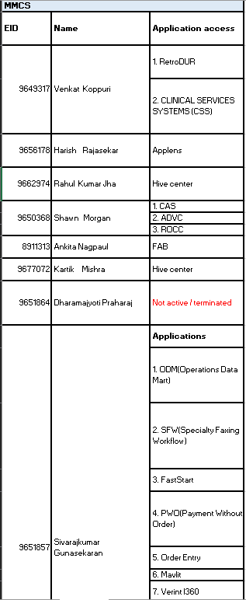 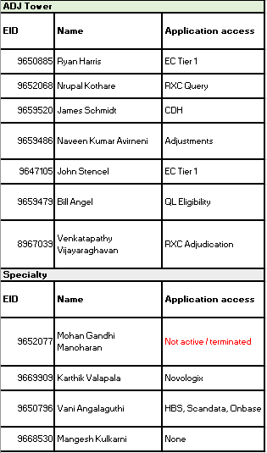

IA observed that 2 out of the 19 active Cognizant employees pulled from all three towers showed up as “Not active/Terminated.” Given there is a time difference between when the original List of active Cognizant user was provided on 07/21/2021 and when the list of application to which these Cognizant employees have access to, provided on 08/23/2021, IA did not gain assurance that all initially active Cognizant employees remained active during this time frame and their level of access to the various applications are based on their job responsibilities.

Attribute not satisfied.

**Attribute 3: For a sample of users with access to ServiceNow and a sample of application within Cognizant responsibility, ensure the following:**

1. **Access request was documented**
2. **Access was approved by authorized personnel**
3. **Access was established per request.**

Following the information provided in Attribute 2 showing a list of 19 Cognizant employees sampled from the total of 185 active Cognizant users, IA sampled 10% of the total of 19 Cognizant users accounting for a total of 3 Cognizant users pulled from all three towers. The Cognizant users and respective application sampled include:

1. 9651857 – FastStart Application
2. 9652068 – RXC Query Application
3. 9669909 – Novologix Application

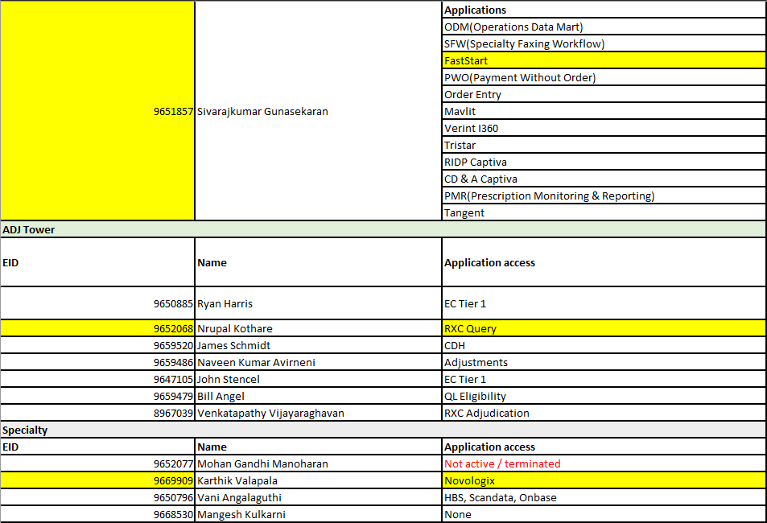

1. **9652068 – RXC Query Application**

On 09/08/2021, IA received from Michael ONeill (Director, IT Systems, RXClaim) evidence showing that access for Nrupal Kothare (EID: 9652068) was documented, access was approved by authorized personnel and access was established per request as seen in [Application Evidence #3](https://cvshealth.auditboardapp.com/download?file_id=125147&name=B.1%20%26%20B.2%20%E2%80%93%20Application%20Evidence%20%233.msg) email thread. *See below for evidence:*

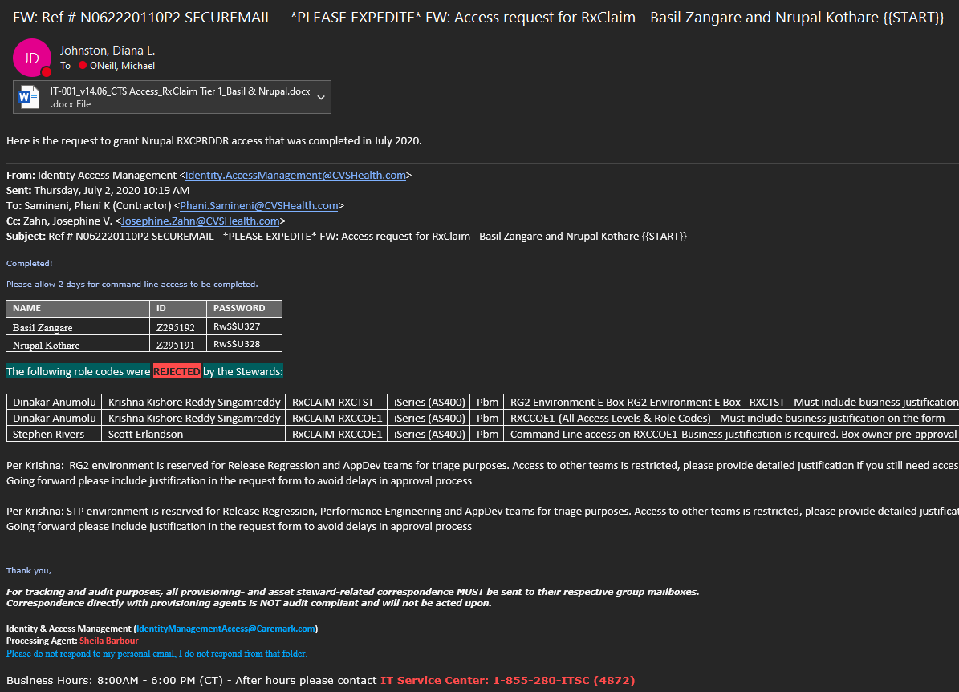

IA observed in the email thread that access to RXC Query Application for Cognizant user EID: 9652068 evidenced series of RxClaim components the cognizant user was granted access by the appropriate personnel in charge, “Stewards” as used in the email. IA also noted that not all access was not granted to Cognizant user 9652068 for the various components of RxClaim. Included in the rejection was the reason for the rejection as seen below:

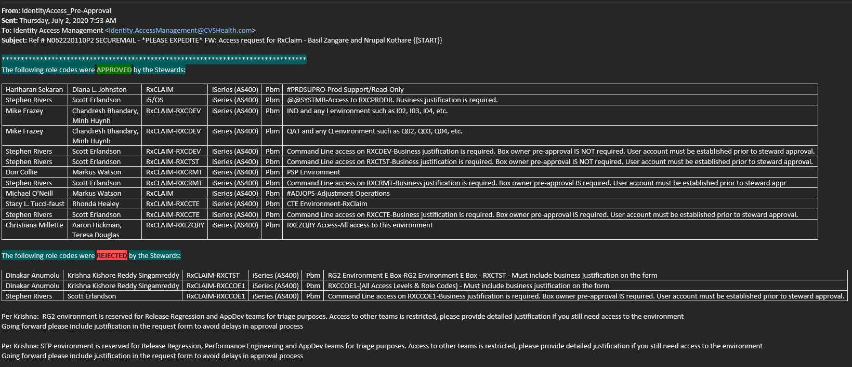

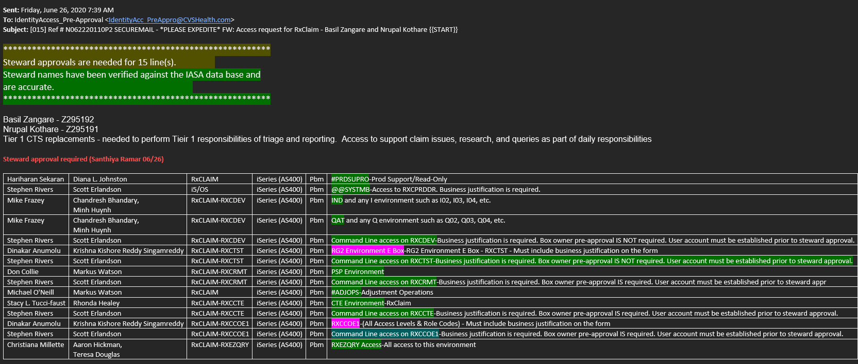

IA also received the CTS Access RxClaim Tier 1 ticket showing who requested access for Cognizant User 9652068 and likewise who approved the request, and likewise the level of access granted. *Reference* [CTS Access RxClaim Tier 1](https://cvshealth.auditboardapp.com/download?file_id=125207&name=IT-001_v14.06_CTS%20Access_RxClaim%20Tier%201_Basil%20%20Nrupal.docx)

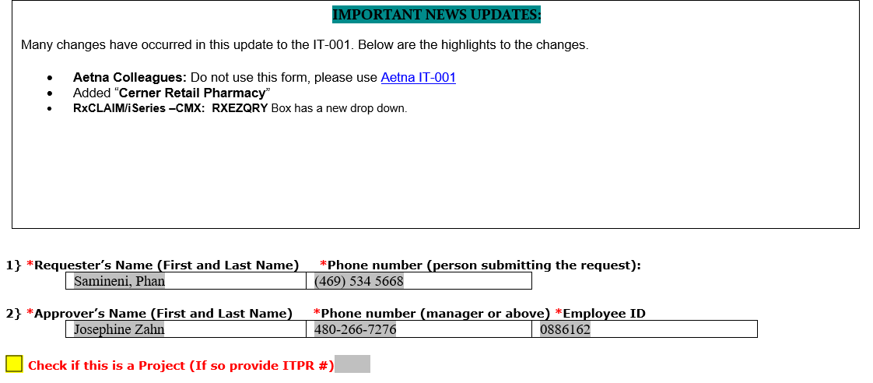

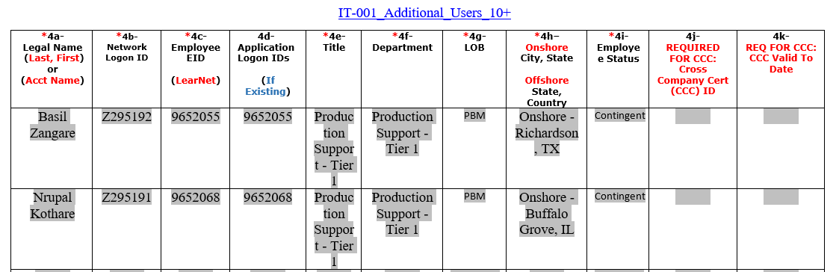

1. **9669909 – Novologix Application**

On 09/08/2021, IA received from Ganesh Gouthamchand evidence showing that access for Karthik Valapala (EID: 9669909) was requested. Reference [NLX Individual Internal User Access Request form](https://cvshealth.auditboardapp.com/download?file_id=125208&name=FW%20New%202020.Copy%20of%20NLX_Individual%20Internal%20User%20Access%20Request%20Form%20v.6.xlsm.msg) email thread. *See below for evidence:*

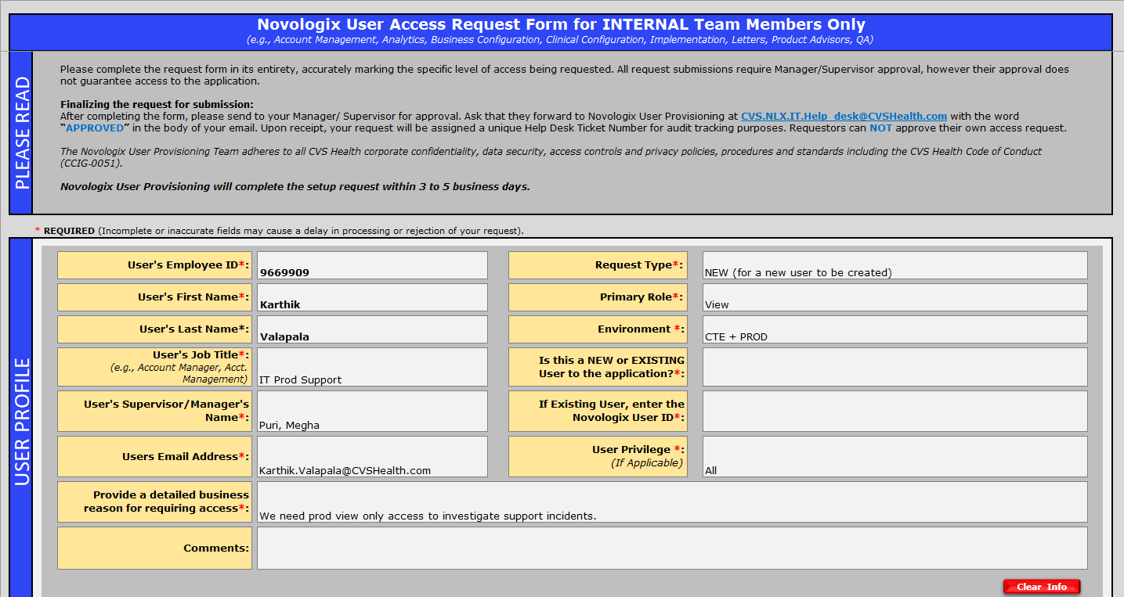

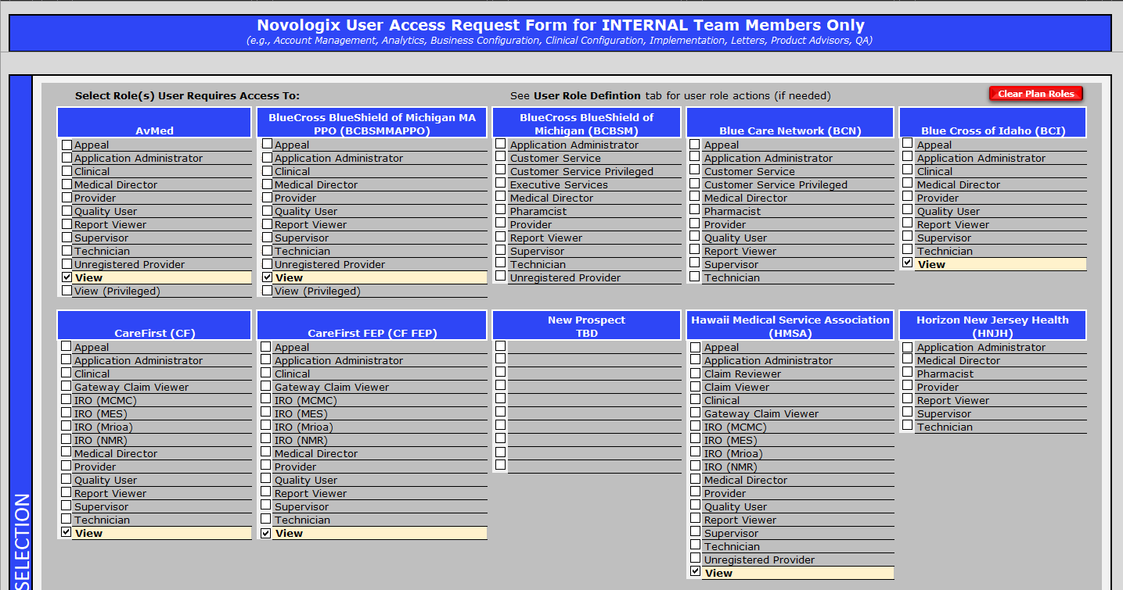

IA also received evidence of the approval that was granted, and the access established for Cognizant User 9669909 into the Novologix Application.

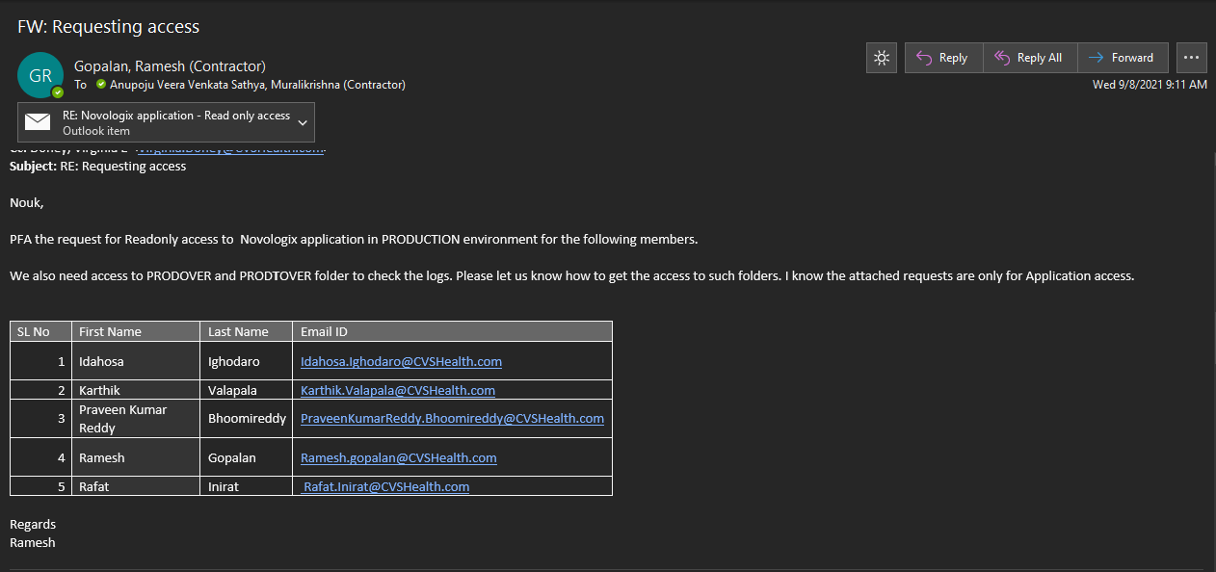

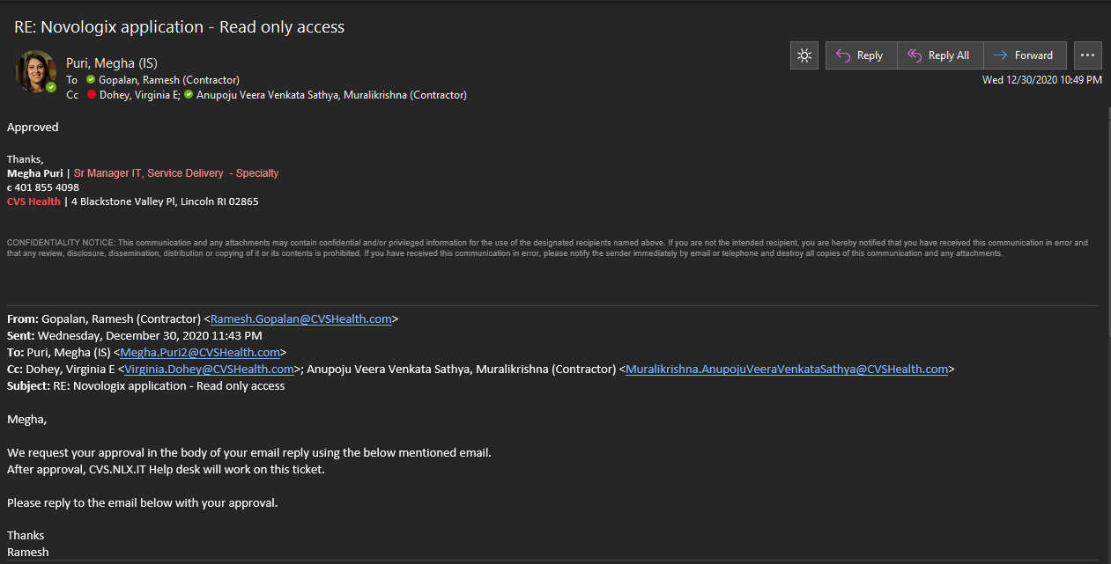

1. **9651857 – FastStart Application**

On 09/08/2021, IA received from Ganesh Gouthamchand evidence showing that access for Sivarajkumar Gunasekaran (EID: 9651857) into the FastStart application was requested. Reference [Ureq400516 TmTrack](https://cvshealth.auditboardapp.com/download?file_id=125225&name=UReq400516%20tmtrack.pdf). *See below for evidence:*

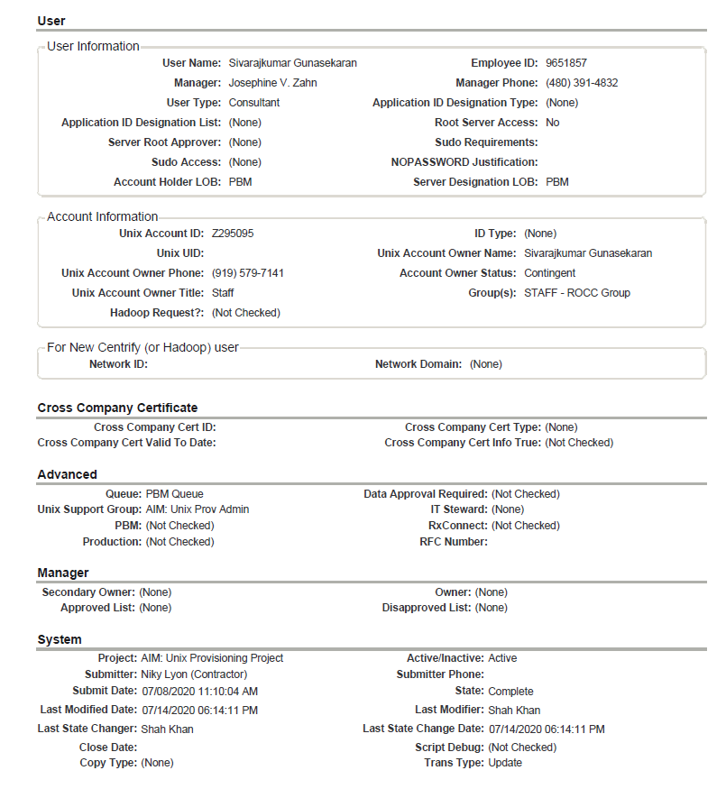

IA also noted in the artifacts received a change history evidencing that the access requested was approved and access was established per request.

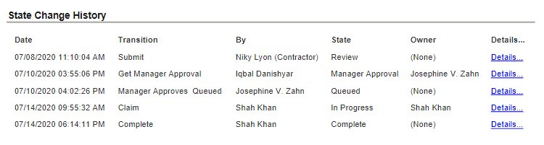

IA gained assurance that for the 3 samples of active Cognizant users 9651857, 9652068 and 9669909 with access to the three applications sampled respectively, access requested was documented, approved by authorized personnel, and established per request. Attribute satisfied.

**Conclusion:**

After carefully reviewing the evidence and artifacts provided, IA did not fully gain assurance that Cognizant personnel access to ServiceNow and other CCSH applications is restricted based on a user’s job responsibility and managed by CVSH Production Support Management team to ensure appropriateness. Controls does not appear to be operating effectively.